LED/relays programming codes

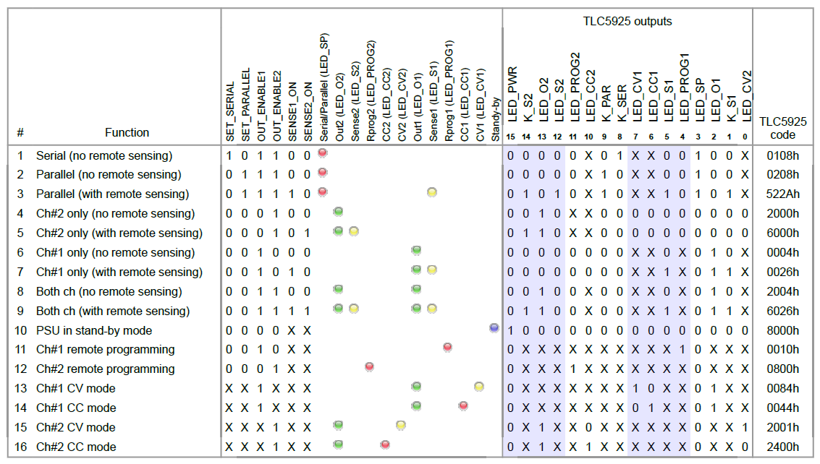
Notes:
- The Remote sense (VOLTage:SENSe) is forbidden when channels are grouped in serial (INSTrument:COUPle:TRACking SERial).
- Before channel grouping in serial or parallel all outputs has to be switched off (OUTPut OFF). New output enable can follow only after 20 ms guard time that is required for relay contacts to stabilize (debouncing).

(add links here)

